**Review Worksheet: Specific Defences**

**Name: ……………………………………………………………..**

*Do these questions, using your learning resources. Look at the “marks” to give you an idea of the level of detail required in the response (formative only – does not count towards your grade). At the end, mark your work, correct it, and fill in the reflection section. Questions marked * require you to use reasoning, inferring and application of knowledge, or perhaps extra research to get the answer. It won’t be right there in the text.*

1: What is meant by the term “Specific Defences” in immunity?

(3 marks)

*…………………………………………………………………………………………………………………….*

*…………………………………………………………………………………………………………………….*

*……………………………………………………………………………………………………………………*

2: What two major types of white blood cell are involved in Specific Immunity?

(2 marks)

…………………………………………………………………………………………………………………….

3: What is an antigen?

(1 mark)

……………………………………………………………………………………………………………………

4: Which part of a pathogen can potentially be antigenic and provoke specific immunity?

(3 marks)

*…………………………………………………………………………………………………………………….*

*…………………………………………………………………………………………………………………….*

*……………………………………………………………………………………………………………………*

5: What things, other than pathogens, can be antigenic and provoke and immune response?

(3 marks)

*…………………………………………………………………………………………………………………….*

*…………………………………………………………………………………………………………………….*

*……………………………………………………………………………………………………………………*

6: What types of cells are Antigen Presenting Cells (APC)?

(2 marks)

*…………………………………………………………………………………………………………………….*

*…………………………………………………………………………………………………………………….*

7: What is the function of APC in specific immunity?

(4 marks)

*…………………………………………………………………………………………………………………….*

*…………………………………………………………………………………………………………………….*

*……………………………………………………………………………………………………………………*

8: Where are lymphocytes produced and where can they be found?

(2 marks)

*…………………………………………………………………………………………………………………….*

*…………………………………………………………………………………………………………………….*

9: B-lymphocytes (B-cells) and T-lymphocytes (T-cells) are both involved in specific immunity. Use the table to compare their production, maturation, location and function.

(4 marks)

|  |  |  |
| --- | --- | --- |
|  | **B-cells** | **T-cells** |
| **Site of Production** |  |  |
| **Site of Maturation** |  |  |
| **Location in Body after maturation** |  |  |
| **Function** |  |  |

10: What type of specific immunity deals with pathogens:

(2 marks)

In body fluids? ………………………………………………………………………………………….

In cells? …………………………………………………………………………………………………..

11: Name the type of immunity that is occurring in the diagram below and describe what is happening at each step.   
(10 marks of 11.5 marks)

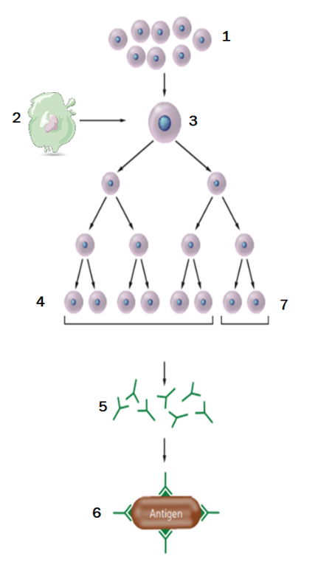

*…………………………………………………………………………………………………………………….*

*…………………………………………………………………………………………………………………….*

*……………………………………………………………………………………………………………………*

*…………………………………………………………………………………………………………………….*

*…………………………………………………………………………………………………………………….*

*……………………………………………………………………………………………………………………*

*…………………………………………………………………………………………………………………….*

*…………………………………………………………………………………………………………………….*

*……………………………………………………………………………………………………………………*

*…………………………………………………………………………………………………………………….*

12: What are antibodies, when are they produced, and what do they do?

(6 marks)

*…………………………………………………………………………………………………………………….*

*…………………………………………………………………………………………………………………….*

*……………………………………………………………………………………………………………………*

13: Describe the four main ways that antibody can neutralise pathogens.

(4 marks)

*…………………………………………………………………………………………………………………….*

*…………………………………………………………………………………………………………………….*

*……………………………………………………………………………………………………………………*

*…………………………………………………………………………………………………………………….*

14: How are pathogens disposed of after being neutralised by antibody?

(1 mark)

*…………………………………………………………………………………………………………………….*

15: Indicate the first and second exposures to the pathogen on the graph below:

(2 marks)

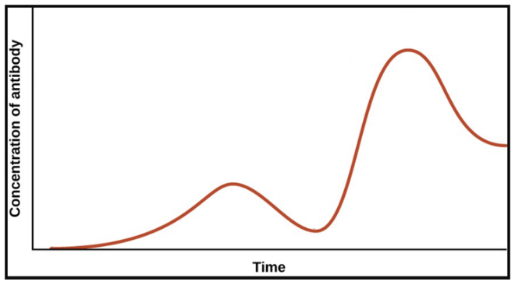

16: Referring to the graph above, explain why symptoms develop after the initial exposure to the pathogen but not after the secondary exposure.

(5 marks)

*…………………………………………………………………………………………………………………….*

*…………………………………………………………………………………………………………………….*

*……………………………………………………………………………………………………………………*

*…………………………………………………………………………………………………………………….*

17: What types of disease causing agents does cell-mediated immunity respond to?

(3 marks)

*…………………………………………………………………………………………………………………….*

*…………………………………………………………………………………………………………………….*

*……………………………………………………………………………………………………………………*

18: Describe in detail the processes shown in the diagram below.

(4 marks)

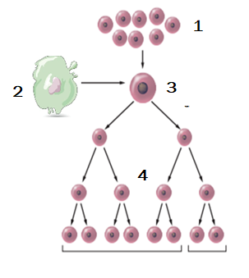*…………………………………………………………………………………………………………………….*

*…………………………………………………………………………………………………………………….*

*……………………………………………………………………………………………………………………*

*…………………………………………………………………………………………………………………….*

*…………………………………………………………………………………………………………………….*

*……………………………………………………………………………………………………………………*

*…………………………………………………………………………………………………………………….*

*…………………………………………………………………………………………………………………….*

19: Four types of T-cell clones are produced. Name each and describe their functions.

(8 marks)

*…………………………………………………………………………………………………………………….*

*…………………………………………………………………………………………………………………….*

*……………………………………………………………………………………………………………………*

*…………………………………………………………………………………………………………………….*

*…………………………………………………………………………………………………………………….*

*…………………………………………………………………………………………………………………….*

*…………………………………………………………………………………………………………………….*



20: Fill in the following table comparing the differences between NS and Endocrine systems:

(6 marks)

|  |  |  |
| --- | --- | --- |
| **Characteristic** | **Nervous System** | **Endocrine System** |
| Nature of Message |  |  |
| Transport of Message |  |  |
| Cells affected |  |  |
| Type of response |  |  |
| Speed of response |  |  |
| Duration of Response |  |  |

Go back and mark your work using the marking key provided. What score did you get? /75

*I included enough detail in my answers.*



*I was able to find information in the text/powerpoint presentation.*

*I was able to reason and infer where the information wasn’t directly in the text (questions with *).*

*I marked my work and wrote down any answers where I missed marks.*